**11 - R710 Proxmox – Cloning Server VMs**

**Log in to Proxmox:**

1. In Firefox, go to : https://192.168.124.**201**:8006

User: root

Password : <whatever>

1. To **use the VM template** from previous step:
2. With the machine stopped, goto this screen, right click on the machine and click on **clone**:  
   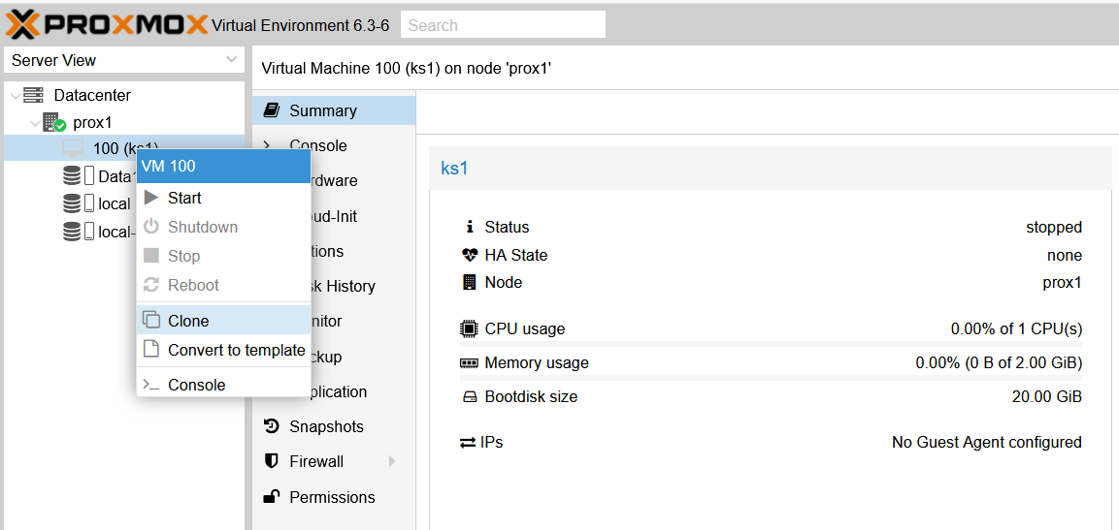  
   to get, and fill in the Name thus:  
   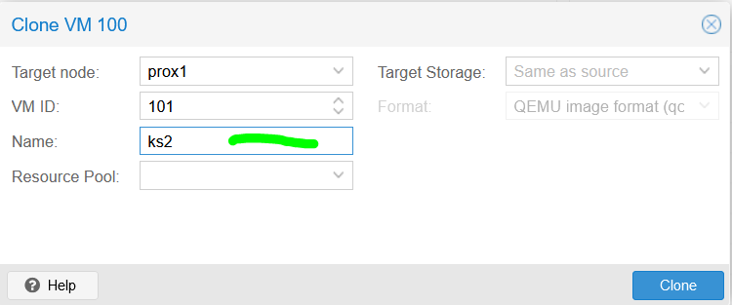
3. Click on Clone and a FULL clone after about a minute is created, thus:  
   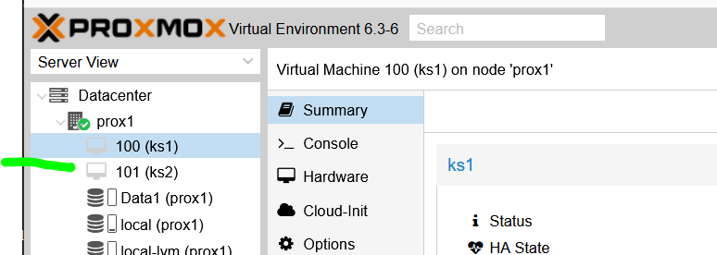
4. Repeat the cloning, to create ks3, thus:  
   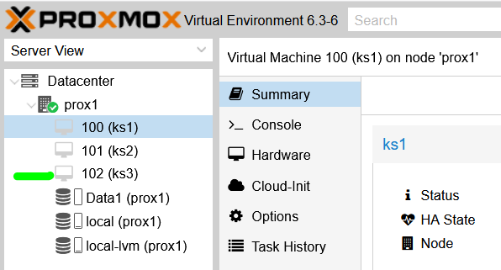
5. Boot up ks2
6. Log into it and follow the section above ”**Changing IP address …**”  
   to change the IP’s of the machines as follow:  
   192.168.124.**203**  
   Also edit / fix the **hostname** and **hosts** files in **/etc** to be **ks2**
7. Reboot the machine for the changes to take effect and when logged back in check that the hostname is correct and do:  
   ip add show  
   to confirm that the IP has changed and is correct.
8. Boot up ks3
9. Log into it and follow the section above ”**Changing IP address …**”  
   to change the IP’s of the machines as follow:  
   192.168.124.**204**  
   Also edit / fix the **hostname** and **hosts** files in **/etc** to be **ks3**
10. Reboot the machine for the changes to take effect and when logged back in check that the hostname is correct and do:  
    ip add show  
    to confirm that the IP has changed and is correct.
11. For each of the machines ks2 and ks3 when they are shut down, goto Cloud-Init and do: Regenerate Image
12. That completes setting up the 3 servers for kubernetes.
13. Now we create workstation kw1 from ks1 clone and store it on Data1, thus:  
    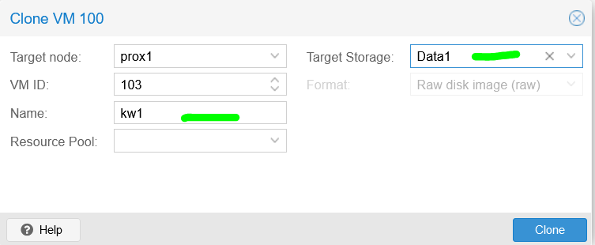

And click on Clone.  
NOTE: it will take more time to create the clone on Data1 (as it’s slower).

1. Repeat this process of cloning ks1 into kw2 and ks1 into kw3, both on Data1
2. NOTE: Things might look like they have completed, but to be sure, start each machine ONE at a time, log in and shut down. You may have to keep trying this until it works. Then do same for next machine. MAKE SURE you only have one machine running at a time as they will have duplicate IP addresses at this point.
3. Now power cycle the R710 (this is done as the next step does not play ball without doing it).
4. When kw1, kw2 and kw3 have been created, for each one, goto the Hardware, thus:  
   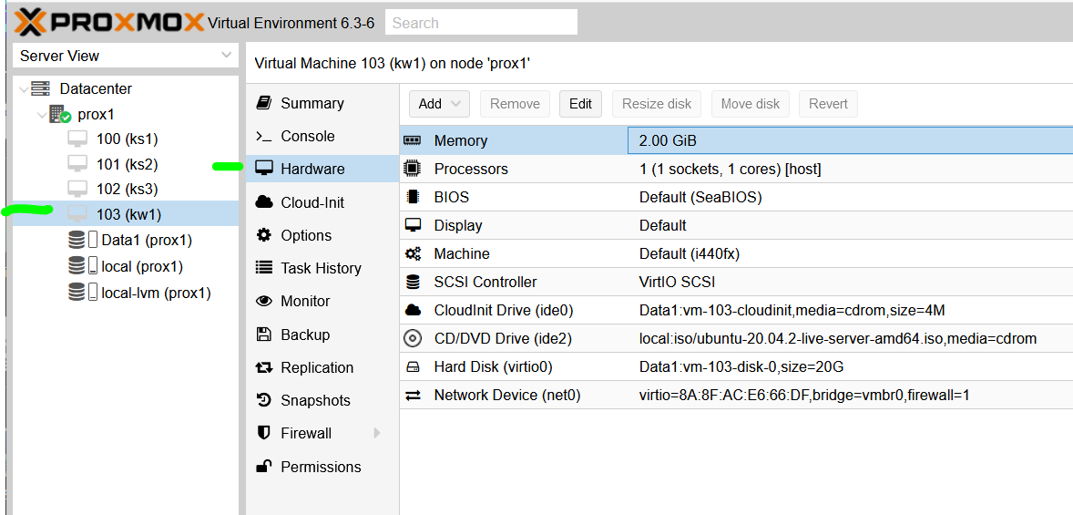  
   and change the Memory, Processors and Hard Disk (using Resize disk => see note below) thus:  
   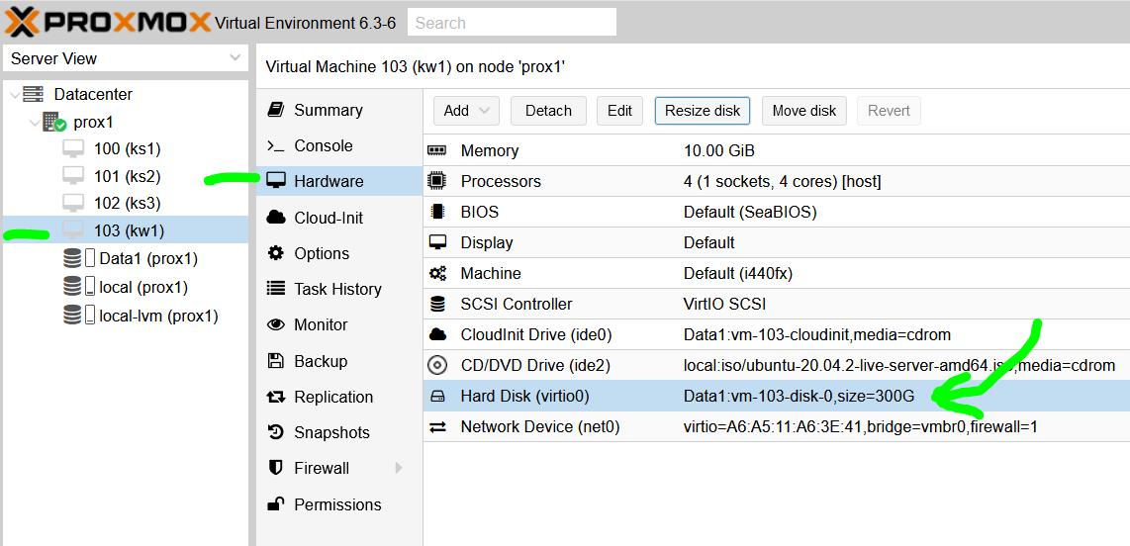  
   NOTE: This process may fail during the resize of the disk …  
   To overcome this I had to reboot the R710 and then Resize the disk by repeatedly adding chunks of 20GB until it got to 200GB, thus:  
   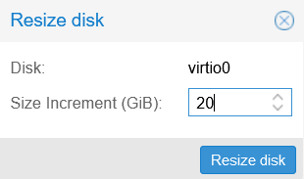  
   NOTE: this only increases the size of the partition, see later on to have linux file system resized, etc)
5. Then go to Cloud-Init for each workstation and Regenerate image.
6. This will take many minutes … to get:  
   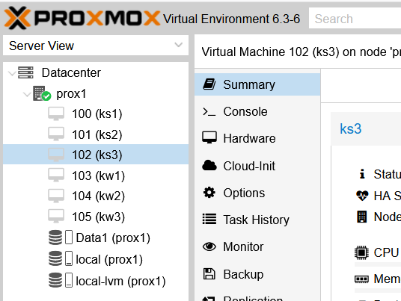
7. Now fix the **hostname**, **hosts** files and IP’s as previous, where the IP’s are:  
   kw1 : 192.168.123.**205**  
   kw1 : 192.168.123.**206**  
   kw1 : 192.168.123.**207**and run: **netplan apply**
8. For each of the machines kw1, kw2 and kw3 when they are shut down, goto Cloud-Init and do: Regenerate Image
9. **Growing disks:**[ the following is mostly gleaned from:  
   <https://blog.dgprasetya.com/promox-extend-lvm-partition-ofly/>

]  
To have each machine grow and use the extra space added to the partition, run up each machine individually and do (as **root**):  
**fdisk /dev/vda  
 w** # to fix GPT, due to previous resize in proxmox GUI **parted /dev/vda**

**print**

**resizepart 3 100%**

**print**

**quit**

**pvdisplay  
pvresize /dev/vda3** # misleading output, so ignore **pvdisplay** # this should show an increase **df -h  
lvdisplay**

**lvresize --extents +100%FREE --resizefs /dev/ubuntu-vg/ubuntu-lv**

**df –h**

And that should show linux seeing the new whole partition size

1. That completes the VM setup, ready for the kubernetes workstations.